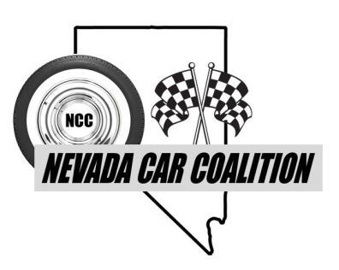



**“Summer Salute” Car Show**

**Saturday, May 24, 2025**

**Rancho San Rafael Park – Reno**

**9:00am to 2:00pm**

**Sponsorships**

The Nevada Car Coalition (NCC), a non-profit organization, is proud to announce that we are hosting the “Summer Salute” Car Show, to be held on May 24, 2025 at Rancho San Rafael Park in Reno.

This car show will be raising funds in honor of our Veterans; specifically supporting the Honor Flight Nevada, Veterans Guest House, and Comstock Lode Quilters.

 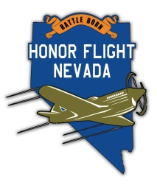

The NCC is asking businesses in the Reno/Carson City/Minden/Gardnerville areas if they would like to donate monies towards this great cause. Below are our various donation levels. With your donation, your name will be advertised on the NCC Facebook page, NCC Website page (https://nevadacarcoalition.com), and at the Show.

|  |  |  |
| --- | --- | --- |
| **Level** | **Donation Range** | **Amount Donated** |
| Platinum | $2000.00 + |  |
| Gold | $1000.00-$1999.99 |  |
| Silver | $500.00-$999.99 |  |
| Bronze | $100.00 to $499.99 |  |
| Other |  |  |

* Mail donation form to:Nevada Car Coalition, attn: Rory Planeta, P.O. Box 51, Minden, NV 89423
* Make check payable to the: Nevada Car Coalition.
* For more information, please contact Al Jewell (775) 781-1747 or allenjewell53@yahoo.com.

(Please Print)

Name: _____________________________________________________________________________

(Last Name) (First Name)

Business Name: _____________________________________________________________________

Mailing Address: ________________________ City: ________________ State: _____ Zip: _________

Business Phone: ( ) ____________________ Cell Phone: ( ) ______________________________

Email address: _______________________________ Website Link:____________________________

**THANK YOU!**