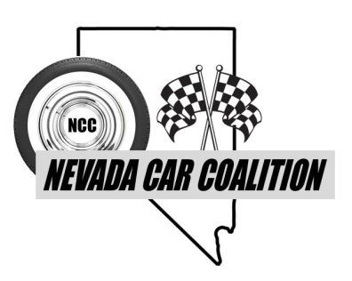



**“Summer Salute” Car Show**

**Saturday, May 24, 2025**

**Rancho San Rafael Park – Reno**

**9:00am to 2:00pm**

**Food Vendor Application**

* Registration Fee **–** Deadline for registration is **May 15, 2025.** 
  + Registration - **$100.00** (All of your sales are for you)
  + Mail registration form to:Nevada Car Coalition, c/o Rory Planeta, P.O. Box 51, Minden, NV 89423
  + Make check payable to: Nevada Car Coalition or go online at nevadacarcoalition.com (fees apply)
* Setup time: Saturday**, May 24, 2025 – 7:00 a.m.** until 9:00am
* Show time: **9:00 a.m. – 2:00 p.m.**
* All proceeds earned go directly to Honor Flight Nevada, Veterans Guest House, and Comstock Lode Quilters.
* For more information, please contact Vicki Jewell (775) 392-0814 or jewellv60@yahoo.com.

(Please Print)

Name: _____________________________________________________________________________

(Last Name) (First Name)

Business Name: _____________________________________________________________________

Type of Business: ____________________________________________________________________

Mailing Address: ________________________ City: ________________ State: _____ Zip: _________

Business Phone: ( ) ____________________ Cell Phone: ( ) ______________________________

Email address: ________________________________

Liability: The following does hereby release Nevada Car Coalition and the Washoe County Parks and Recreation departments and their employees of liability in conjunction with any damage to exhibitors, person and/or anyone operating exhibitor’s space, merchandise and/or personal property due to fire, theft, breakage, acts of God, or any kind of public disorder or disturbance during the day’s event. Please ensure you have the proper County/State Health permits.

**Signed** Date